
Koneru Lakshmaiah Education Foundation
(Deemed to be University estd. u/s. 3 of the UGC Act, 1956)
Off-Campus: Bachupally-Gandimaisamma Road, Bowrampet, Hyderabad, Telangana - 500 043. Phone No: 7815926816, www.klh.edu.in

STUDENT CASE STUDY EXECUTION REPORT
Department | FED
Subject | DSA-2
Academic Year | 1-III Semester(2025-2026)
Faculty Name | Mohd Razia Alangir Banu
Student Name | Nuguri Siri
Roll Number | 2520030309
Branch | CSE
Course Outcome | Apply Binary Search Trees (BST) and self-balancing AVL Trees to construct, insert, delete, and search hierarchical datasets, demonstrating correct rotation operations and O(log n) performance guarantees in real-world file indexing and dictionary scenarios.

Case Study Topic: CivicEye – Smart City Incident Monitoring & Response System
Work Done Summary:
The CivicEye system was developed to manage smart city incident records efficiently using BST and AVL Trees. BST operations such as insertion, searching, and deletion were implemented to store incident data hierarchically. To improve performance and maintain balance, AVL Trees with rotation operations were used. The system achieved faster searching, efficient incident management, and optimized O(log n) performance for large datasets.

Implementation Details:
- Created an Incident Node structure to store Incident ID, location, and status details.
- Implemented BST operations such as insertion, searching, and deletion for managing incident records.
- Developed AVL Tree insertion with balancing conditions to maintain optimized tree height.
- Implemented AVL rotation operations including Left Rotation, Right Rotation, Left-Right Rotation, and Right-Left Rotation.
- Compared BST and AVL Tree performance based on search efficiency, balancing, and time complexity using smart city incident datasets

Result: Screenshots / Output
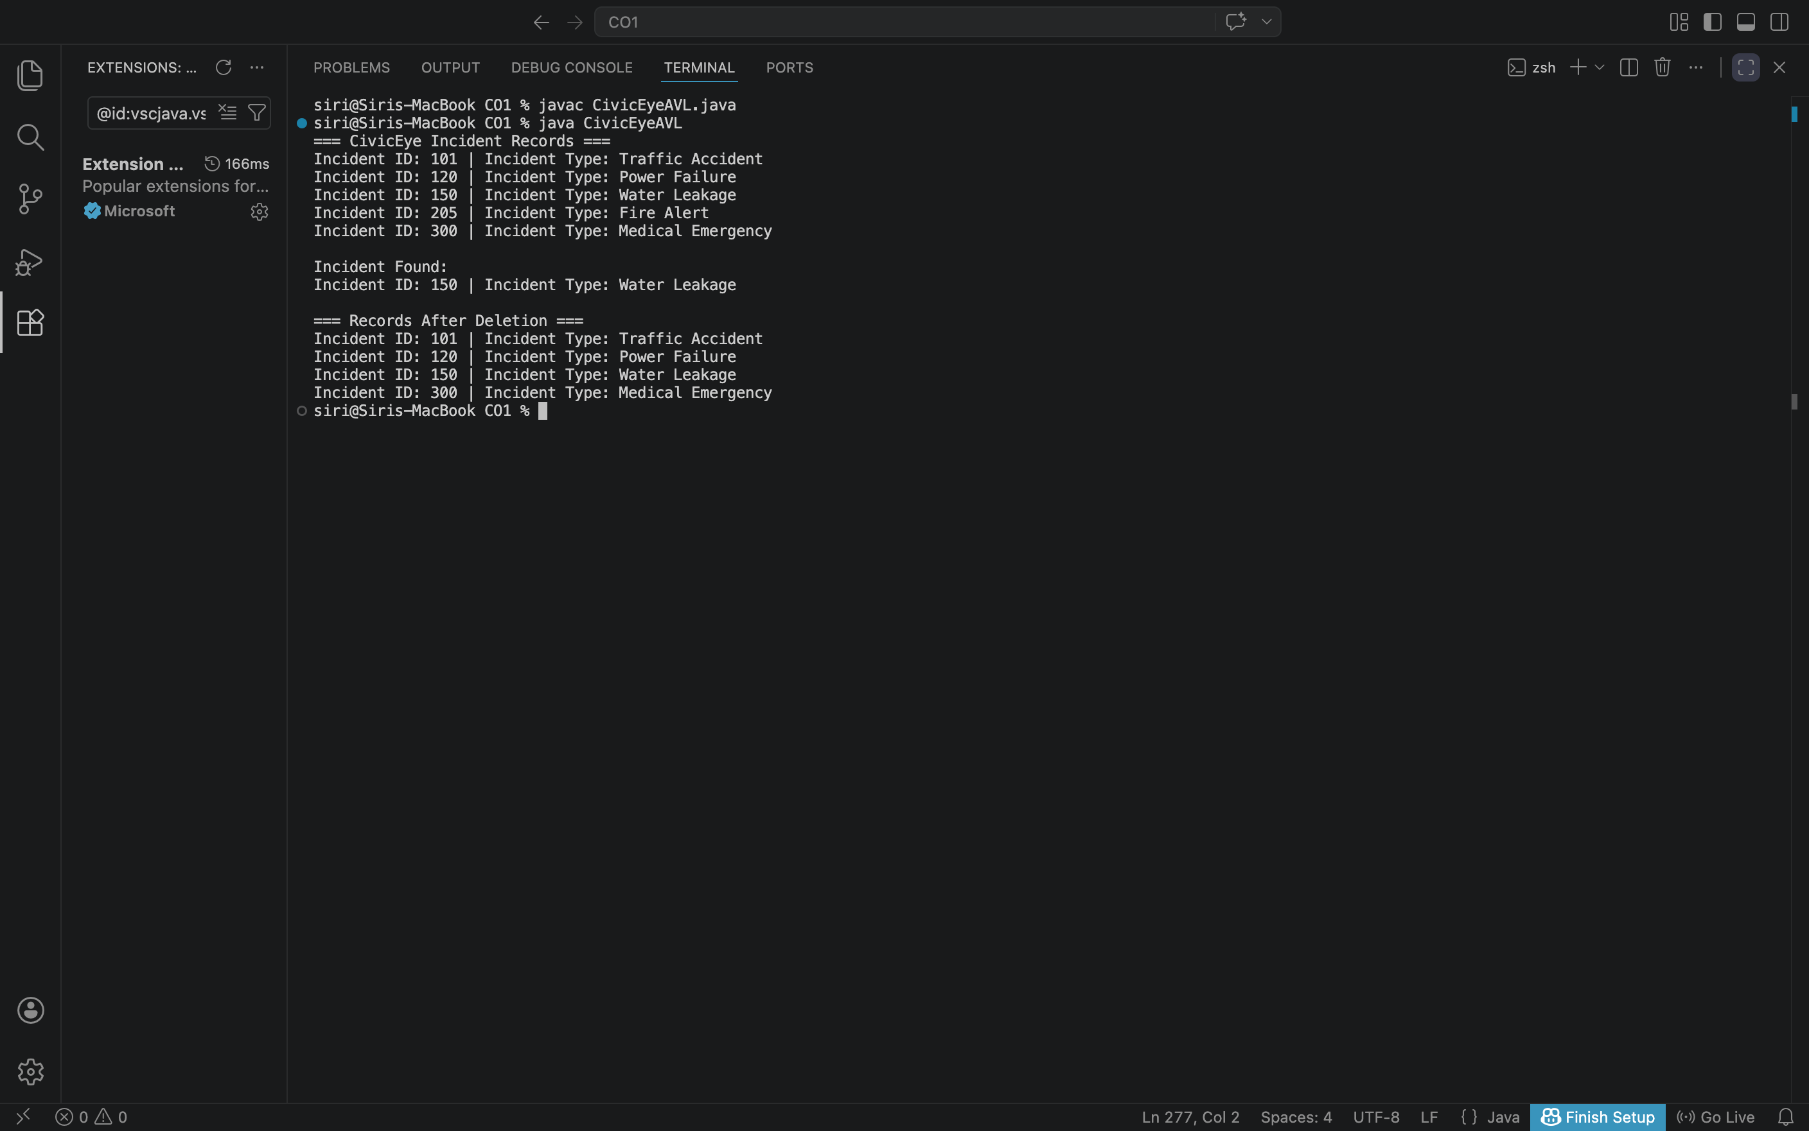

The output shows that the CivicEye system successfully managed smart city incident records using AVL Trees. Incident data was inserted, searched, and deleted efficiently while maintaining a balanced tree structure. The AVL Tree improved searching speed and ensured optimized O(log n) performance compared to a normal BST. This demonstrates that AVL Trees are suitable for real-time smart city incident monitoring and emergency data management systems.
GitHub Link: https://github.com/siripanchajanya-netizen/DSA-2
NOTE: The Code and Screenshots have been uploaded in the above github link

Student Signature: Faculty Signature:

